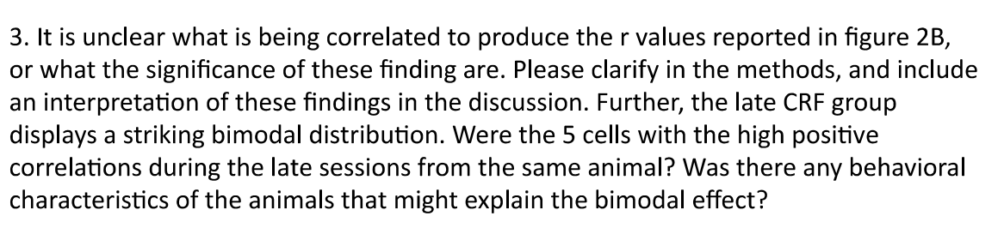

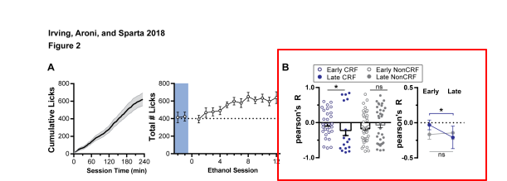

* **ANSWER: WHAT CORRELATIONS ARE SHOWN AND WHY IMPORTANT**
  + These are the correlations of the cumulative # of licks and the unit's normalized firing rate, analyzed in 5 min bins.
  + The major take-away is that relationship between CRF units firing rates and licking behavior changes after repeated binge drinking cycles, where non-CRF had no significantly shift in their distribution.
* **ANSWER: RE THE BI-MODAL DISTRIBUTION**
  + Regarding the bimodal distribution of fig 2B, late CRF:
    - primarily due to 1 mouse, which contained 4 out of the 5 positively correlated units.
    - There was nothing distinct in his behavior to explain the effect
  + 